environmental congress 15th October 2019

This inspired me to document our last venture immediately.
The CONGRESS was a big success. 120 students took part and everyone attended at least 4 out of 6 workshops.

Our students were most impressed by the ecological footprints.
Inspired by them we ordered the full set, which is available for rent for schools.
They were advising other groups
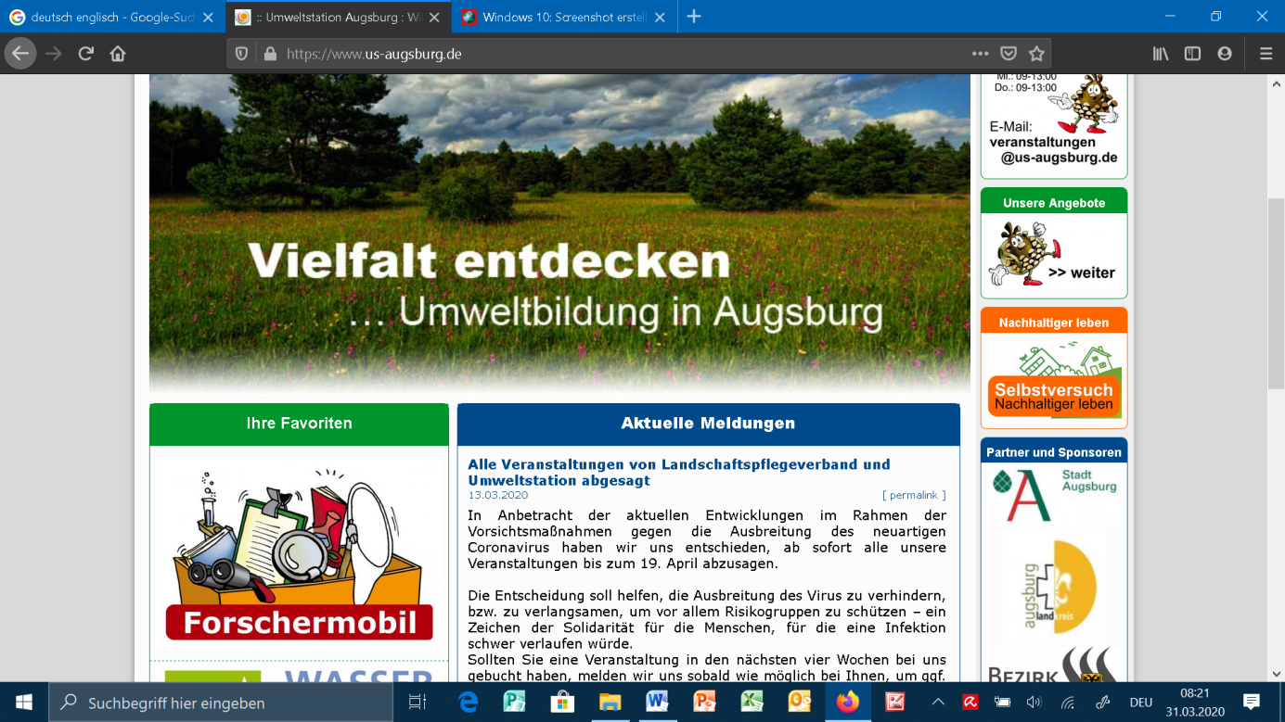

The Augsburg environmental station supports schools in many different ways in many different projects

