...3.6 billion people do. Because they don’t have one.
We should all care more about toilets.
AND WATER !! A crucial contribution to personal hygiene and health - based mainly on access to running water.
If you have one, thank it, your family, the region and the country you and your family live in have a toilet, because over 50% of the world's population does not have one. Life without a toilet is dirty, dangerous and undignified.
Public health depends on toilets. Toilets also drive improvements in gender equality, education, economics and the environment.
There will be no sustainable future without toilets. Governments must work four times faster and ensure toilets for all by 2030.
Fortunately the world situation has improved considerably.

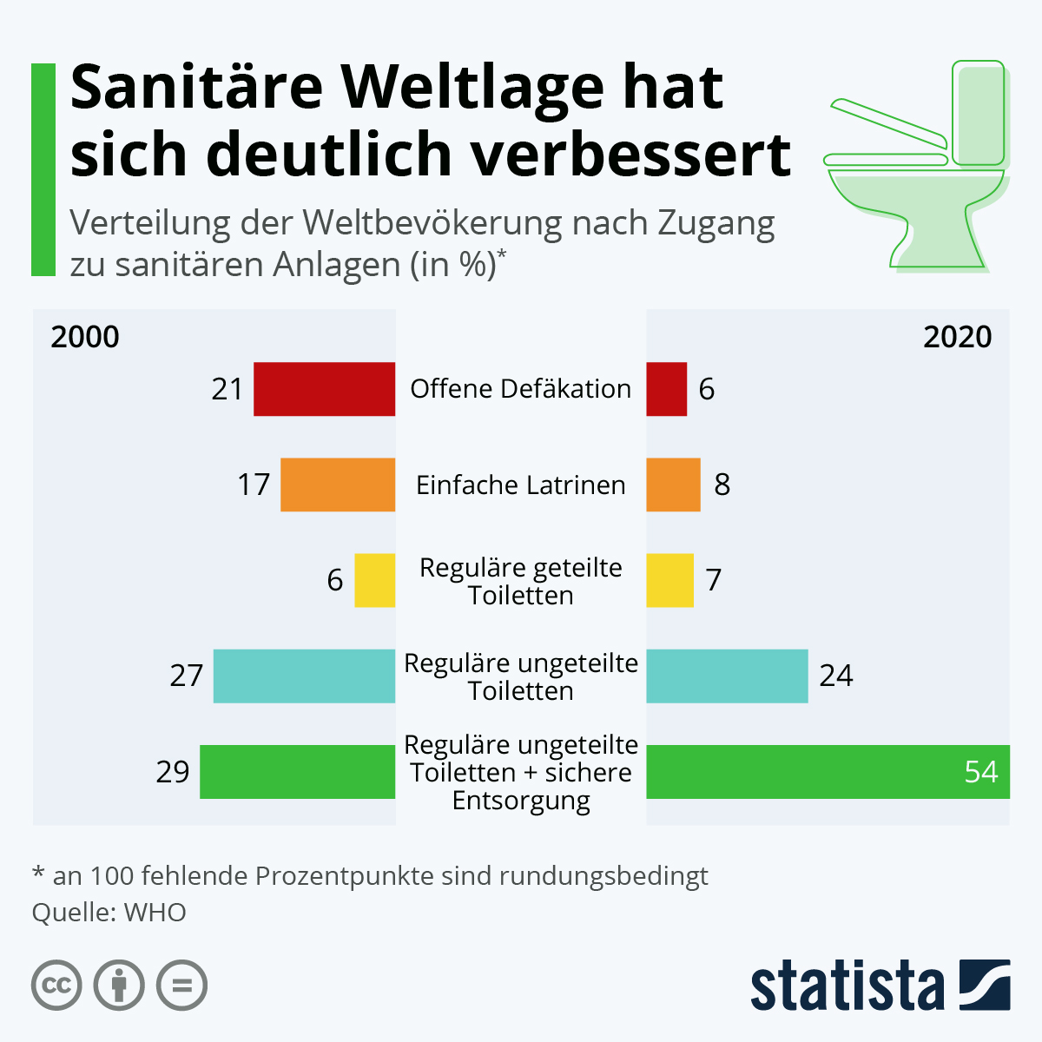
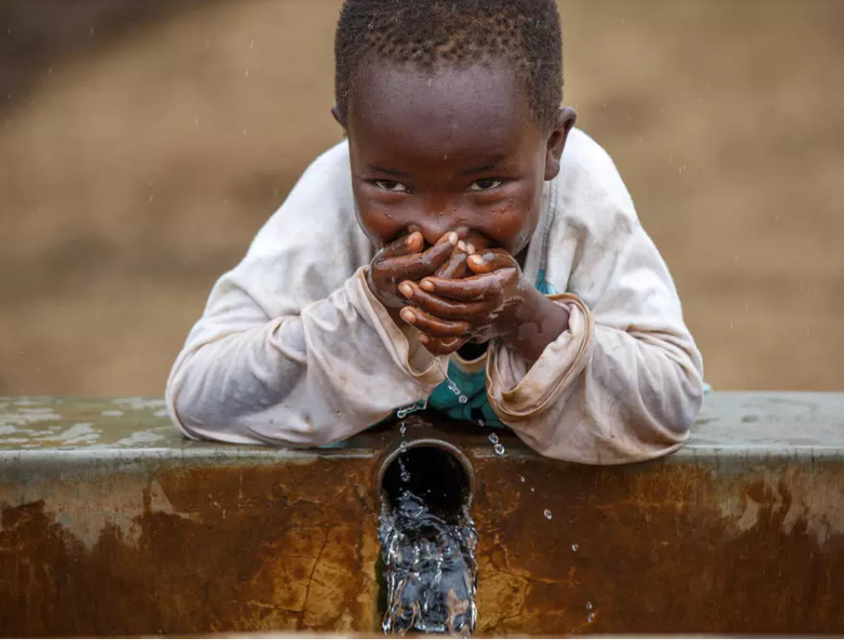
What does water mean?
What would be without water?

